Write a program of Missionaries and Cannibals using python code

Aim :To solve the Missionaries and Cannibals problem using Python.
Procedure:
Represent the number of missionaries and cannibals on the left bank.
Move people across the river using a boat of capacity 2.
Ensure cannibals never outnumber missionaries on either bank.
Use Breadth-First Search (BFS) to find a valid sequence of moves.
Print the steps from the start state to the goal state.

Python Code:
from collections import deque
start = (3, 3, 1) # (Missionaries, Cannibals, Boat)
goal = (0, 0, 0)
moves = [(1,0),(2,0),(0,1),(0,2),(1,1)]
def valid(state):
m, c, b = state
if m < 0 or c < 0 or m > 3 or c > 3:
return False
if (m > 0 and m < c):
return False
if ((3-m) > 0 and (3-m) < (3-c)):
return False
return True
queue = deque([(start, [start])])
visited = set()
while queue:
state, path = queue.popleft()
if state == goal:
print("Solution Path:")
for step in path:
print(step)
break
if state in visited:
continue
visited.add(state)
m, c, b = state
for dm, dc in moves:
if b == 1:
new = (m-dm, c-dc, 0)
else:
new = (m+dm, c+dc, 1)
if valid(new):
queue.append((new, path+[new]))

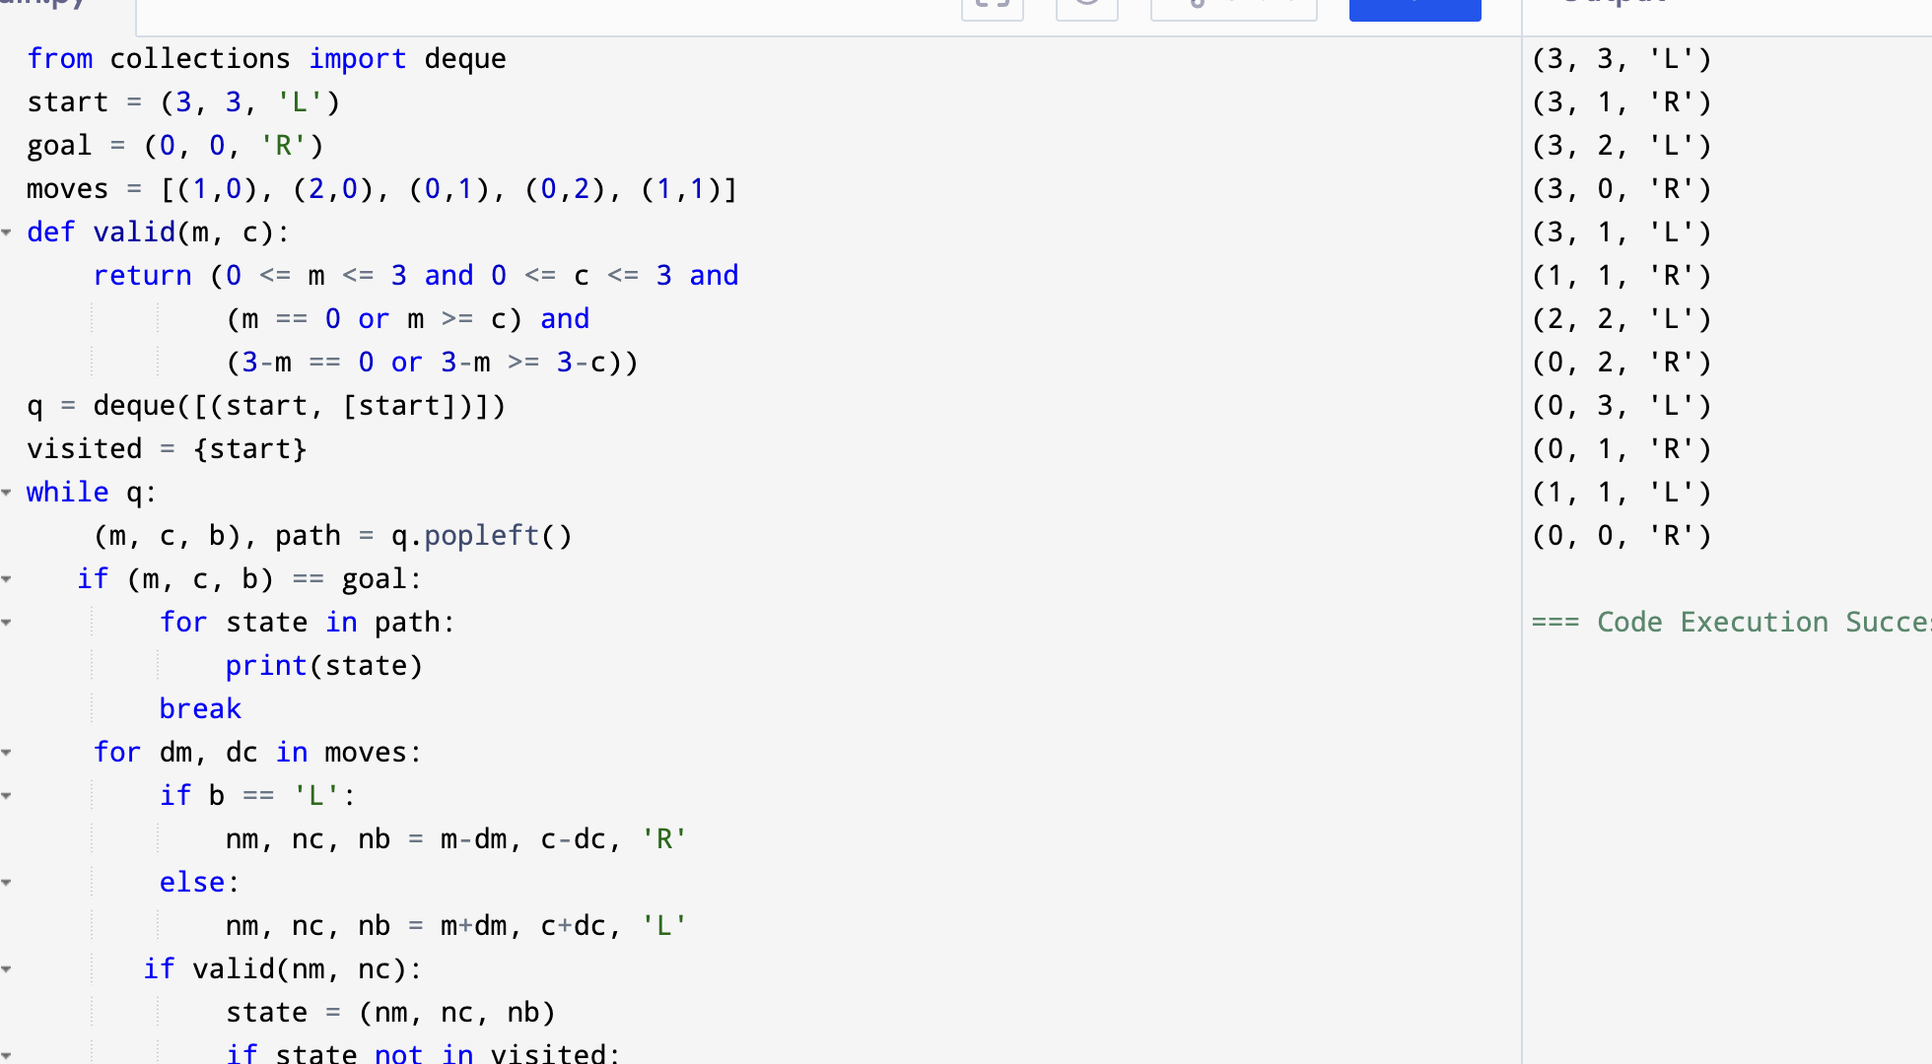
Output:

Flowchart:

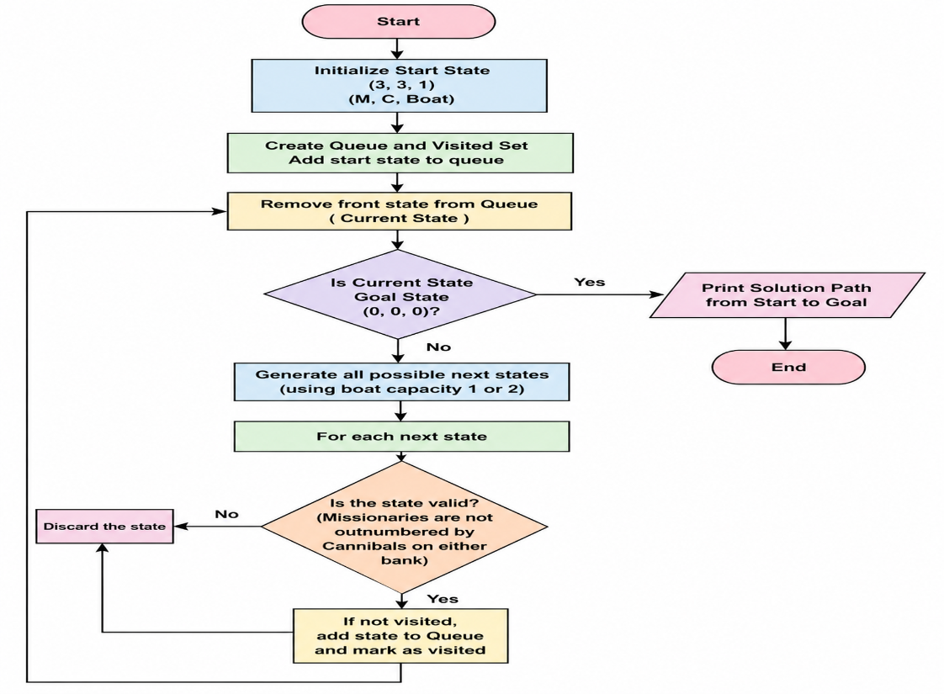

Result: Hence, Missionaries and Cannibals problem has solved

